Technical Reference Manual

MyTasks

Ryan Britt

**Overview**

All the data gathered by this app is put in the database to be later analyzed. Therefore, the heart of this app is the database, which is described through code in TaskDatabaseHelper.java and the data store, which is described in theTaskDataStore.java file. The second most important area is the reports generated; the code for that is in Reports.java. The database design for this app follows, but most of the technical detail for this app is in a separate file labeled **Doxygen Technical Reference.pdf**. This is documentation similar to javadocs, which details all the information about the code itself.

**Database Design:**

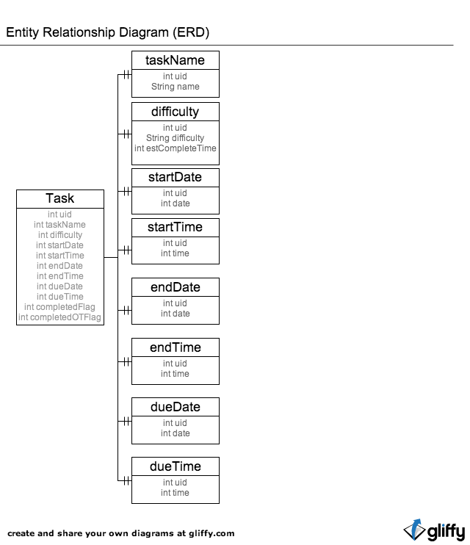

The database is designed as the ER diagram above shows. There is a main table, which holds a unique id per task and a foreign key to that particular task’s name, difficulty, startDate, startTime, endDate, endTime, dueDate, and dueTime. Each one of these foreign keys is broken out into its own table. The main table also has a field for an integer value of whether the task has been completed or not (completedFlag) and whether the task has been completed on time or not (completedOTFlag). For each of these values, the number 1 means yes and the number 0 means no, as displayed by the use of a public static constant in TaskDatabaseHelper.java. Each of the other tables are broken down into unique IDs and then the text or integer that they represent. For the difficulty table, there is also an estimated time taken linked with each entry into the table.